**W5 A1**

**Steps to Complete Git Tasks**

**1. Clone the Repository**

1. Open your terminal or Git Bash.
2. Run the following command to clone the repository:
3. git clone https://github.com/vaibha-v19/dynamic-elements-waits-sel.git
4. Navigate to the cloned repository directory:
5. cd dynamic-elements-waits-sel

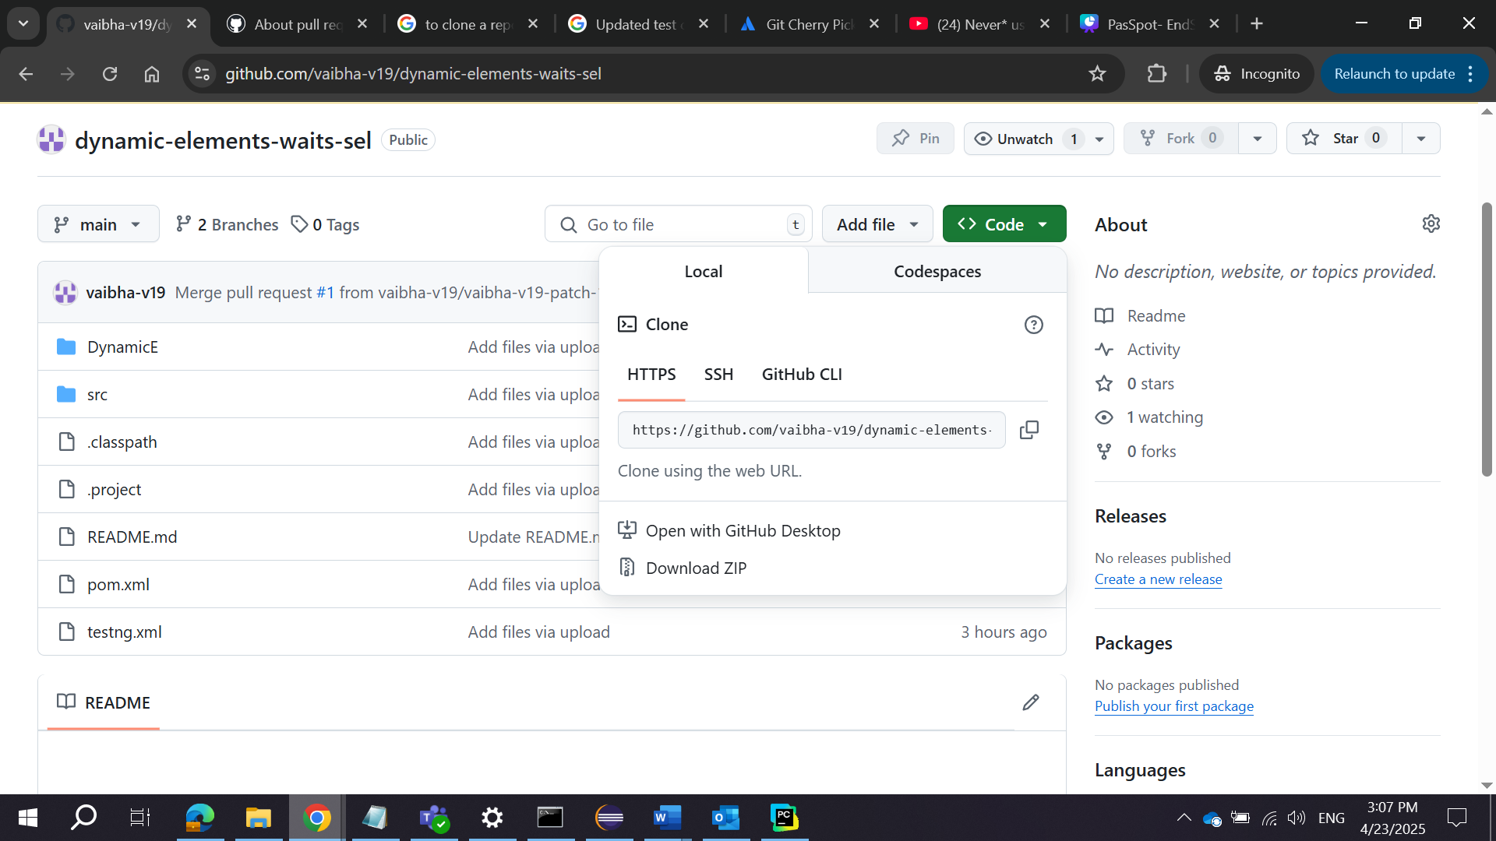

**2. Create a New Branch**

1. Create a new branch for your changes:
2. git checkout -b feature-update

Replace feature-update with a meaningful branch name.

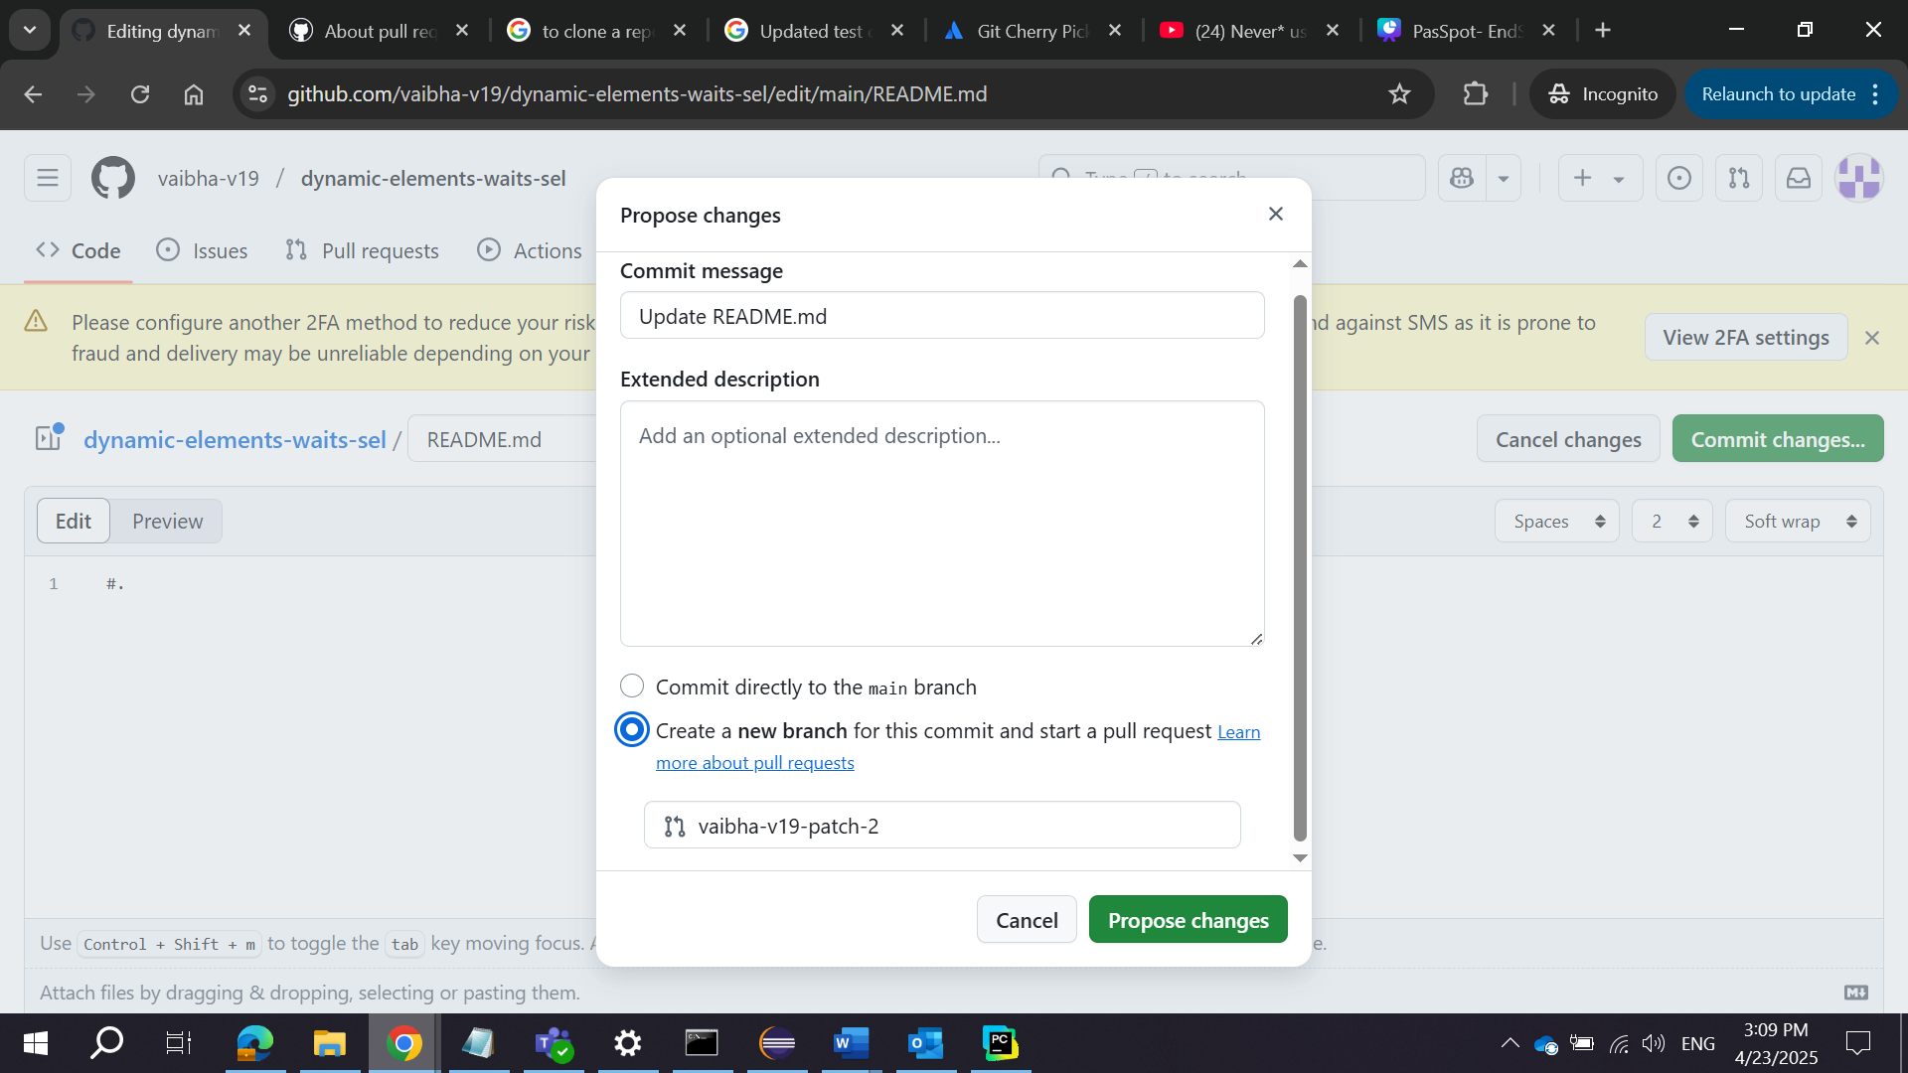

**3. Make Changes to the Code**

1. Open the project in your preferred code editor (e.g., VS Code).
2. Make the necessary changes to the code or files.
3. Save the changes.

**4. Stage and Commit the Changes**

1. Stage the changes:
2. git add .
3. Commit the changes with a meaningful message:
4. git commit -m "Updated dynamic elements handling logic"

**5. Push the Branch to the Remote Repository**

1. Push the branch to the remote repository:
2. git push origin feature-update

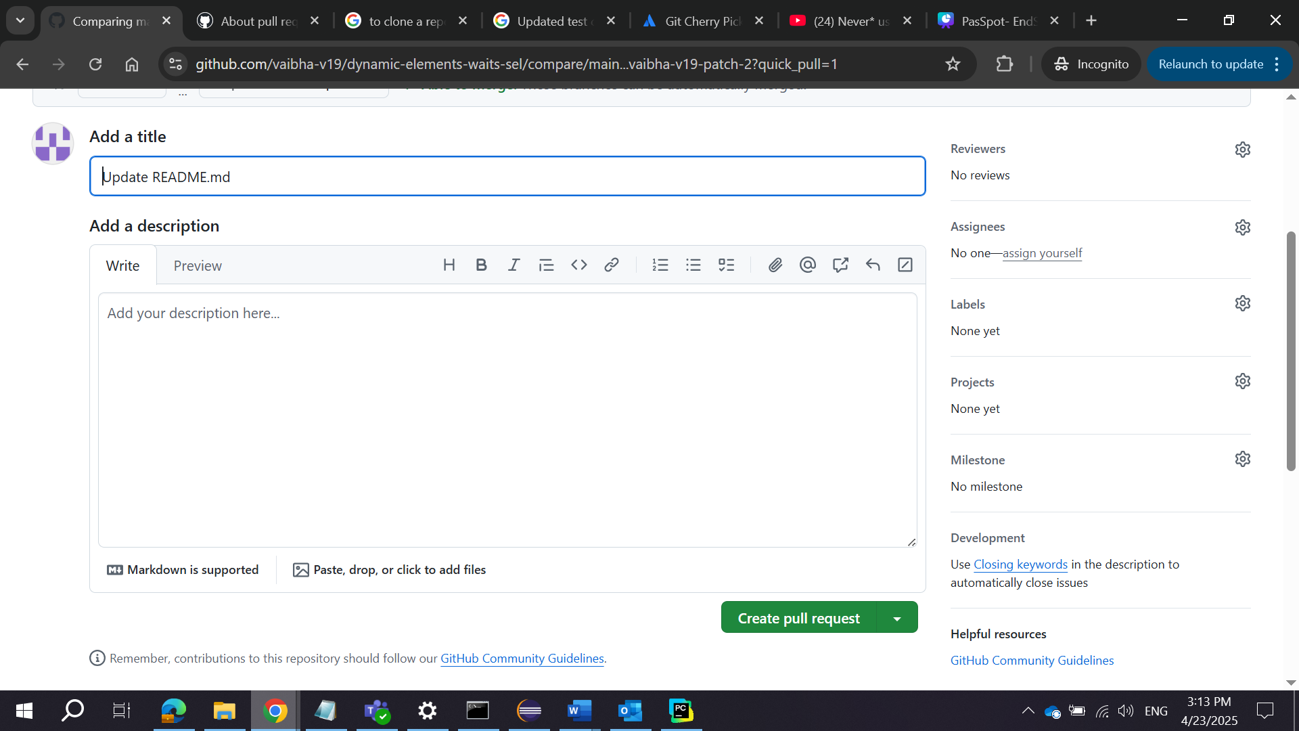

**6. Create a Pull Request (PR)**

1. Go to the GitHub repository: <https://github.com/vaibha-v19/dynamic-elements-waits-sel>.
2. Click on the **“Compare & pull request”** button that appears after pushing the branch.
3. Add a title and description for the pull request.
4. Click **“Create pull request”**.

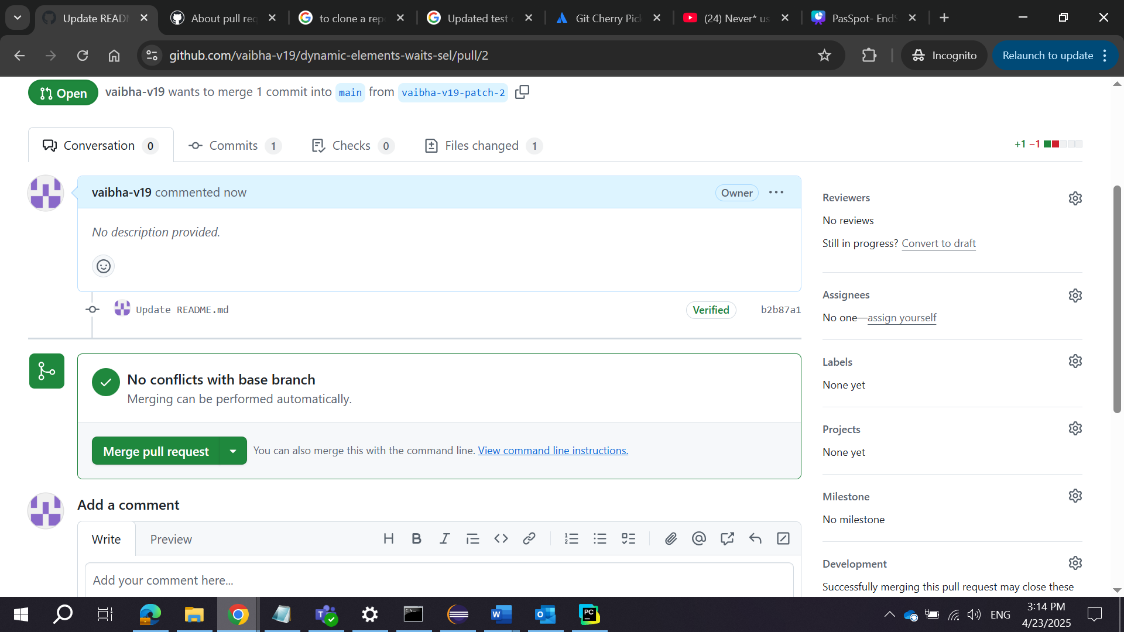

**7. Review and Merge the Pull Request**

1. Once the pull request is created, review the changes.
2. If you have write access to the repository, click **“Merge pull request”**.
3. Confirm the merge by clicking **“Confirm merge”**.
4. Delete the branch (optional) by clicking **“Delete branch”**.

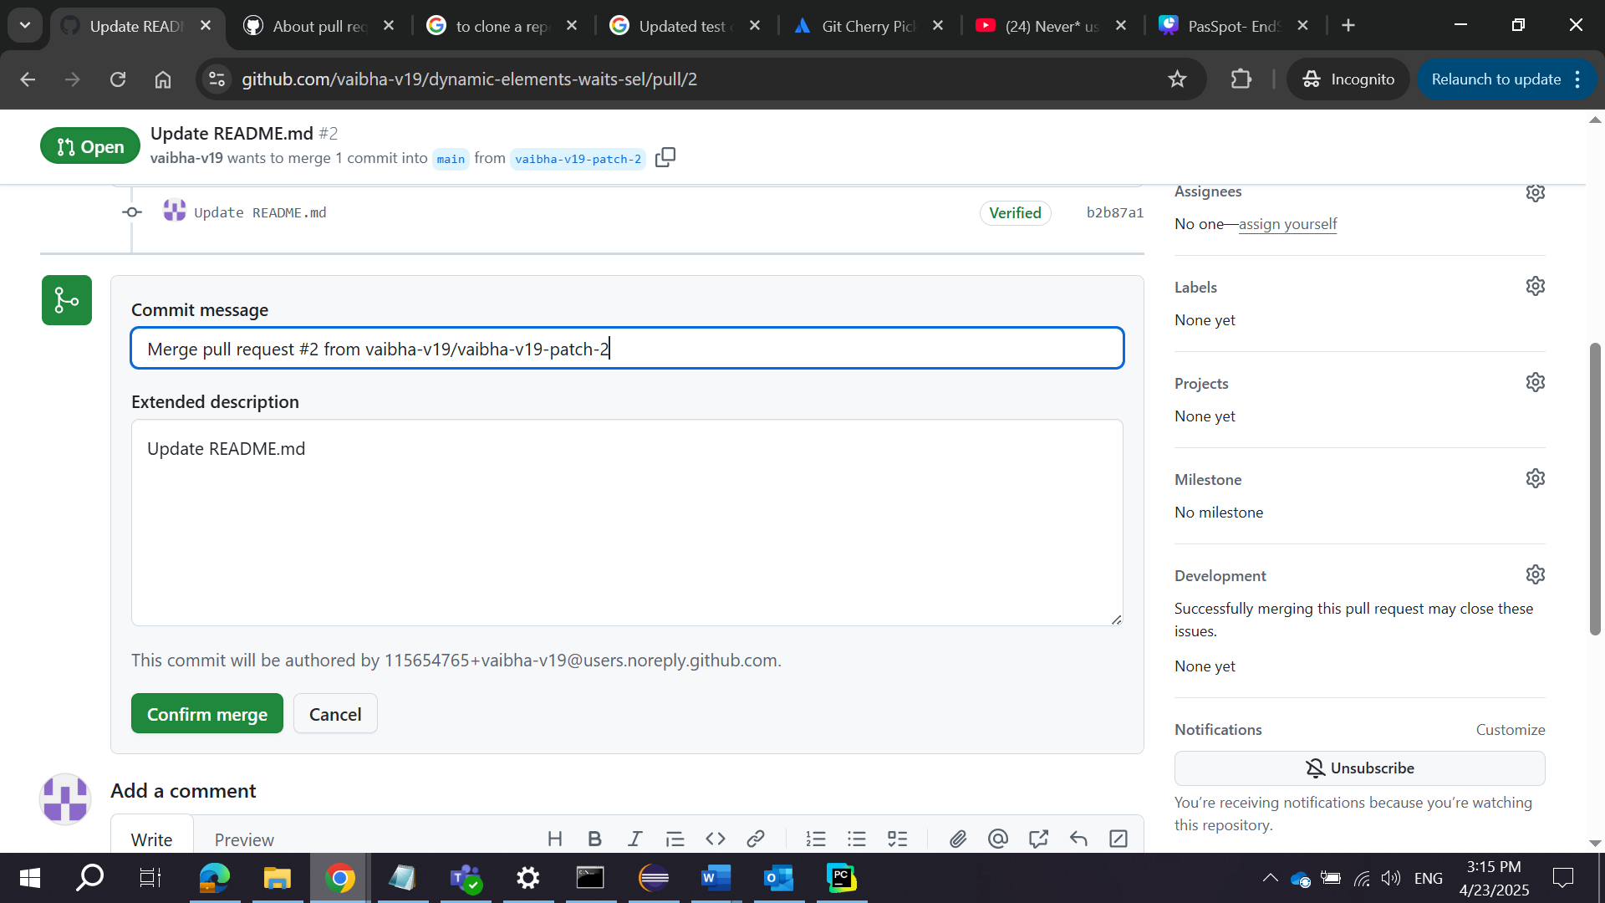

**8. Verify the Changes**

1. Pull the latest changes to the main branch:
2. git checkout main
3. git pull origin main
4. Verify that the changes have been merged successfully.

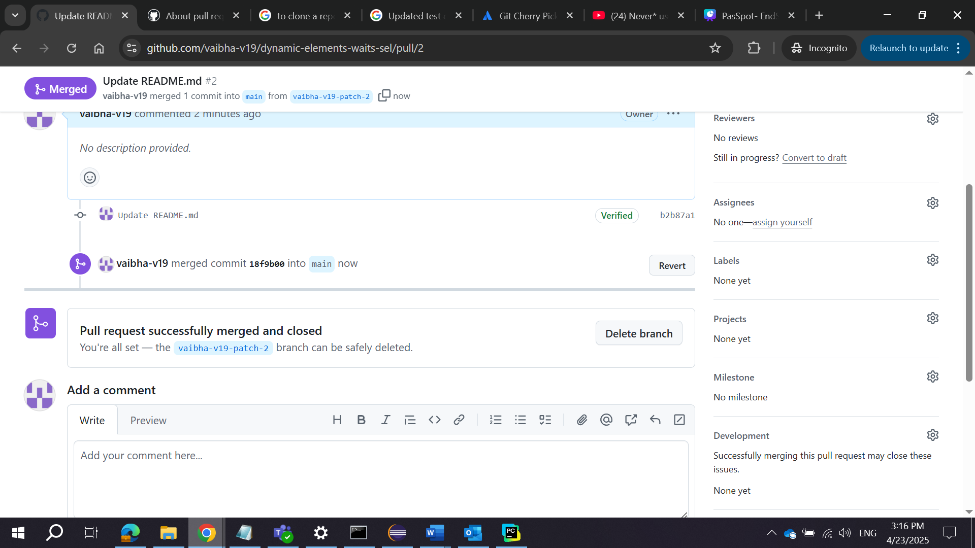

**Submission**

* Submit the link to the pull request: <https://github.com/vaibha-v19/dynamic-elements-waits-sel/pull/1>.